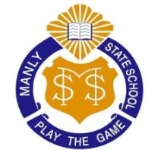
Year 4 Newsletter
2019 ~ Term 1
Welcome to Year 4 ! Initially we will spend time getting to know each other, refreshing class and school expectations, and developing routines for the year. Below is an overview of the topics that will be covered in our key learning areas.

In this unit, students will listen to and read the novel Esio Trot by Roald Dahl. The assessment for this unit will be to write an imaginative short story which has a well-planned and structured plot. Students will demonstrate their ability to use rich description and varied sentence structure to engage their audience.
Reading
During Semester 1 there will be a strong focus on developing the reading capabilities of the students. In Year 4 our specific focus will be on developing the comprehension skills of Predicting and analysing the Author’s Purpose.
Geography
In this unit students will investigate the ways in which waste is managed in our local area and how individuals can manage waste more sustainably.
This term students will continue to extend their understanding of place value and speed up their recall of multiplication facts. They will order sequences of simple fractions and use the properties of numbers to continue patters. Students will represent times in different ways and use instruments to accurately measure length.

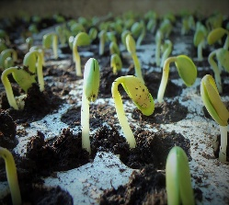
Science We will participate in a ‘Mangroves and the Environment’ excursion during week 10 this term. More details to come soon.
The students will be investigating lifecycles, examining relationships between living things and their dependence on each other and on the environment.

Art & Technology
Art - Students will participate in our very popular ‘Reader’s Theatre’ throughout the term. Their assessment will be to collaborate with others in a small group to plan and perform a drama for their peers.
Technology - Students will transform data into information. They will present a digital solution with meaningful information on how lunch waste can be reduced at Manly State School.
Students will receive weekly homework. This will include spelling activities, number facts and reading.
Reminder: All students will receive Mathletics and Reading Eggspress accounts shortly to consolidate and extend their learning and these can be used at home.
Physical Education (PE)
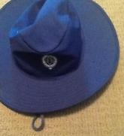
All Year 4 students have their Physical Education lessons on Wednesday this term. They should wear their sports uniform for these lessons.
School Uniform
Our Manly State School uniform is to be worn proudly. The formal day uniform is to be worn every day except for the days when the class has a PE lesson. The formal uniform requires all black shoes. Check the Manly State School website to ensure students are wearing the correct uniform. In our climate, a sun-safe, broad-brimmed hat is essential when playing outside. A school hat must be worn to and from school every day.
Reminder: Label all uniform items and lunch boxes!!!
NO HAT, NO PLAY!!!
School Parades
This year school parades will be altered to be more relevant to different year levels. There will be whole school parades and alternating fortnightly parades for Years 1-3 and Years 4-6. These parades will be held on FRIDAY mornings at 9:00am. Parents are welcome to join us in the Hall at this time. Check the school website for more details.
From the Year 4 teaching team:
Mrs Harris (4H) lharr131@eq.edu.au
Mrs Davis (4D) mdavi700@eq.edu.au
Mr Anderson (4A) sxand5@eq.edu.au
Mrs Lambert (4DL) slamb26@eq.edu.au
Mrs Day (4DL) kjday0@eq.edu.au

