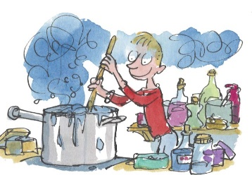
Year 2 Newsletter – Term 1

Dear Parents and Carers,
We have had a great couple of days, getting to know each other, refreshing class and school expectations and developing routines for the year. Coming up in the next few weeks will be the parent information night. This will give all parents a chance to meet the teacher and get to know a little about the year, class routines and expectations.
Year 2 Parent information session: Tuesday 12th February - 5.30pm – 6pm
Below is a brief overview of the topics that will be covered in our key learning areas.
English:
In this unit students will listen to, read and view a range of texts. We will be specifically studying procedural texts and informative texts. We will be learning about the structure and the language elements found in both types of writing. This week we have begun reading ‘George’s Marvellous Medicine’ by Roald Dahl, and we are focusing on nouns and noun groups. We will also be sequencing procedural texts.
Mathematics:
In this unit, the students will be ordering days of the week and months of the year, using calendars and connecting seasons to the months of the year. They will also be measuring and comparing lengths of objects. They will be counting in 2’s, 5’s and 10’s and representing two digit numbers. They will be problem solving and developing understanding of number facts.
Geography:
In this unit, the students will be developing an understanding of the concept of scale. Students will investigate their links with places locally and globally and the connection that Aboriginal and Torres Strait Islander People maintain with Country. The students will also enhance their understanding of the geographical divisions of the world.
Science:
In this unit students will understand how a push or pull affects how an object moves or changes it shape. They will investigate and explain how pushes and pulls cause movement in objects used in their daily lives. They will be creating toys to demonstrate and explain how forces affect their toy.

Homework:
Homework is given out every Monday and is to be returned on Friday. Home readers are to be changed as needed so that reading occurs every day. Homework consists of spelling, maths and reading.
Physical Education:
PE is on a Tuesday with Mr Barben. All children are expected to wear their sports uniform and suitable footwear on this day.
Library:
2J- Tuesday 2D- Wednesday
2VC- Thursday 2B- Thursday
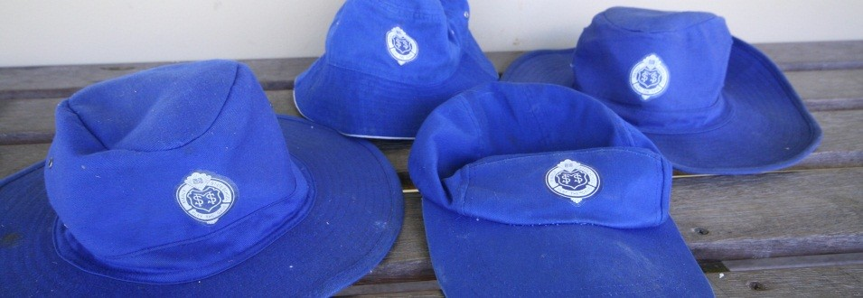
School Uniform:
Our Manly State School uniform is to be worn proudly. The formal day uniform is to be worn every day except for the days when the class has a PE lesson. Check the Manly State School website to ensure students are wearing the correct uniform. The correct school hat is an essential when playing outside. No hat, no play.
We are looking forward to an enjoyable year ahead.

From the Year 2 teaching team.
Helen Verbakel Toni Dixon Natalie Clarke
Angela Bannister Bridget Jacob

